Suffix Trees – based on Ukkonen’s Algorithm

Tree Construction:
Note: The construction of the suffix tree was not picked from any website.
1. The data structure used contains:
a) 256 child nodes, for each character (lowercase letters, punctuations, and spaces etc...)
b) An integer representing the index that is the start of the substring that led to that node.
c) An integer representing the index that is the end of the substring that ended at that node.
d) Indication if that node is a leaf node
i) If it is not a leaf node, value is -1
ii) If it is a leaf node then the index of the substring that ended at that node.

Conditions to take care of while Inserting a new substring into the tree:
1. Start at the root node and if the first character of the substring does not already have a substring starting with that character, then create a new node and join it to the leaf node

2. If there is already a node starting with that particular character then 4 cases occur:
a)If the initial part of the substring matches to a part of a node but after that there is a mismatch, a split has to be done, a new node has to be created with the next letter of the new substring, one node for the next old substring (where mismatch happened) and the end values in the parent node have to be changed.
b) If the initial part of the substring matches to a node (till the end of the node – match-len = start - end +1 of current node) but after that there is still a match (after moving to a next node), we have to keep moving until either the substring ends or condition 2(a) above is reached.
c) This will be a special case of 2(a) where the node above which the split has to occur already has valid children, we need to make sure that these children are not lost and the split happens at the above level with all other nodes attaching correctly.

Pre- Processing:
1. The lines of the story were concatenated and stored as title and story in a structure.

2. If there were more than 2 lines that had a length <= 3, then that means that the line after that belonged to the next story, that was the methodology used to separate stories from one another.

3. All the text in the story was converted to lower case to make the matching case insensitive.

4. Extra spaces were removed.

5. Moral of the story was joined along with the story for simplicity purposes

6. 3 file approach was used to seperate the interface from the implementation.

A sample tree created using the above logic:

Please refer to the diagramatic representation shown below with a sample string: wolf, wolf would warn

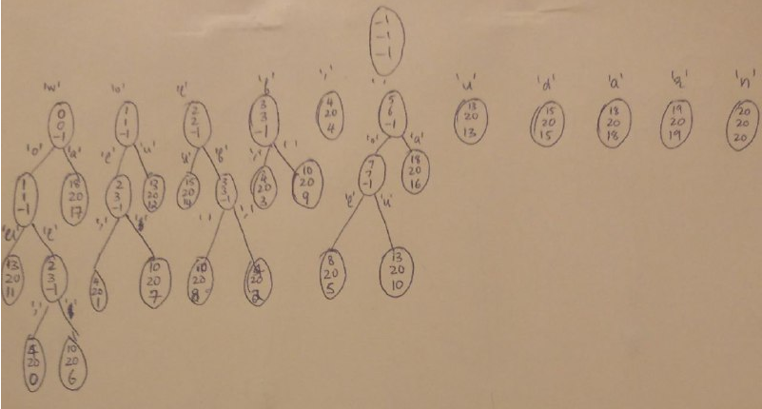

Complexity:
1. For each suffix string, the complexity of entering that suffix into the tree is asymptotically logarithmic

2. This logarithmic procedure has to be done once for each suffix. So for a text of ‘n’ characters, the complexity of creating the tree will be O(n(log n))

3. Freeing the tree using DFS has complexity O(log n)

How Suffix trees are used here:
For each story, a suffix tree is created and the appropriate traversals are done for this tree. As soon as the required traversal is done, the memory is freed using a Depth first traversal of the suffix tree which has a logarithmic complexity.
At a time only a suffix tree for one story will be in memory as all other trees will be freed.

1. The suffix tree is traversed to find all occurances of a given string

2. The suffix tree is traversed to the leftmost occurance of the given string and if that isn’t found then the longest existing prefix of the query string is found in the story and the location and story from that point are printed.

3. The documents are ranked based on the significance using information that can be conveyed from the suffix tree of that story.

PART 1: The suffix tree is traversed to find all occurances of a given string

1. The letters in the query string are matched one at a time until the end of the query string is reached.

2. In case some letter occurs in the query string which is not available for that node in the suffix tree then we “fall off” the tree and say that there was no occurance.

3. If we have reached the end of the query string and not “fallen off the tree” then we call a recursive function which goes through all the children of that node where we stopped, at and prints the suffix number for that if it is a leaf node. This function also prints the whole sentence in which the above query string occured by searching sequentially for the nearest ‘.’

Complexity: O(z * logm) where m is the length of the query string and z is the number of leaf nodes that the node we stopped at has.

PART 2:The suffix tree is traversed to the leftmost occurance of the given string and if that isn’t found then the longest existing prefix of the query string is found in the story and the location and story from that point are printed.

1. The letters in the query string are matched one at a time until the end of the query string is reached.

2. In case some letter occurs in the query string which is not available for that node in the suffix tree then we “fall off” the tree and say that there was no occurance.

3. If we have reached the end of the query string and not “fallen off the tree” then we call a recursive function which goes through all the children of that node where we stopped, and adds the suffix number to an array (global variable)

4. After all leaf nodes have been visited the minimum value is picked from the array (this is the starting position of the leftmost occurance of the query string) this value and the whole string after the point of match is printed

5. If there is no exact match of the query string, one letter is cut down every time from the query string and the function to check if the string exists in the tree is run again until the largest prefix is found which occurs in the story.

6. The moment this is found, the leaf nodes of that node are visited and the suffix number is added to an array and step 4 repeats.

Complexity: In worst case, assuming the string found is only one letter of the query string, our compexity becomes O(m * (z log m)) + O(z) (last term is complexity to find the minimum in array)

PART 3: The documents are ranked based on the significance using information that can be conveyed from the suffix tree of that story.

The scoring mechanism:
1. The query string is sliced into separate words, and the number of occurances and the left most occurance for each word is checked.

2. There are 3 heuristics for scoring. Each category carries 30 points and every story is giving a score out of 100. The higher the score, the better it is ranked.

3. The heutistics are:
i. Ratio of length of tale to no. of times needed words appear (the lower this value the better) ii. Number of words in the query that were there in the tale
iii. Whether the sequence of the words appearing in the tale was same as the query string

4. The documents are then given a rank based on the score and documents having same score have same rank.

5. Sorting is done to put the ranks in order.

Complexity :
1. Scoring : O(z log(m/p))
Where p is the number of words, m is the length of the query string and z is the number of leaf nodes in each case. Includes time to find the match in the suffix tree for p words (each of average length m/p)
Scoring and ranking are constant time operations
2. Sorting: Bubble sort O(n log(n))

Roshni Venkatesh
01FB15ECS247

